Task 2: Core Security Concepts Explainer
1. The CIA Triad (Confidentiality, Integrity, Availability)
The CIA Triad is a fundamental concept in information security. It consists of Confidentiality, Integrity and Availability, which represent three essential goals of cybersecurity. A secure system must protect information from unauthorized access, prevent improper changes, and ensure that authorized users can access it when required.
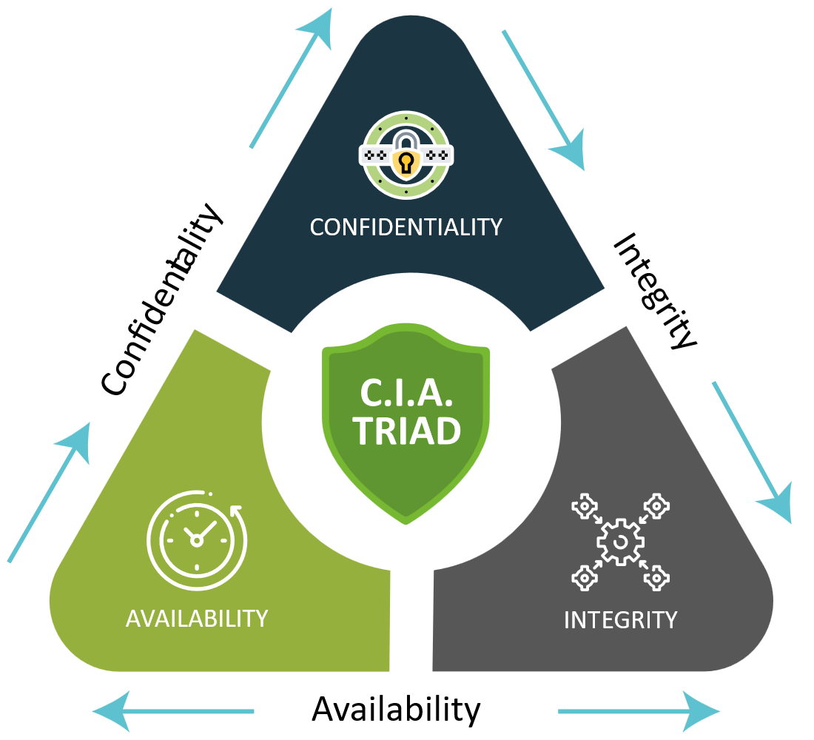

Confidentiality

Definition: Confidentiality ensures that sensitive information is accessible only to authorized individuals. It protects data from being viewed or disclosed by unauthorized users.

Real-World Scenario: Online Banking & Personal Records.
When you access your online banking account, the connection is protected using encryption such as HTTPS. This helps prevent unauthorized individuals on the same network from viewing sensitive information such as your account details or transaction history. A breach of confidentiality could expose private information and potentially result in identity theft or financial loss.

Integrity

Definition: Integrity ensures that information remains accurate, complete, and reliable. It protects data from being altered, deleted, or manipulated without proper authorization.

Real-World Scenario: Bank Transactions.
When you transfer money through an online banking system, the transaction details must remain unchanged throughout the process. If an attacker were able to modify the amount or destination account without authorization, the integrity of the data would be compromised.

Availability

Definition: Availability ensures that systems, information services remain accessible to authorized users whenever they are needed. A secure system should not only protect data but also remain operational and accessible.

Real-World Scenario: Online Services.
When you need to access your bank account, the banking website or application should be available and functioning properly. Attacks such as a Distributed Denial-of-Service (DDoS) attack can overwhelm a service with excessive traffic, preventing legitimate users from accessing it.
2. Encryption vs. Hashing

Encryption and hashing are both techniques that transform readable information into an altered form using mathematical algorithms. However, they serve different purposes. Encryption is reversible, meaning the original information can be recovered using the appropriate key. Hashing on the other hand is intended to be irreversible and is commonly used for data integrity checks and secure password storage.

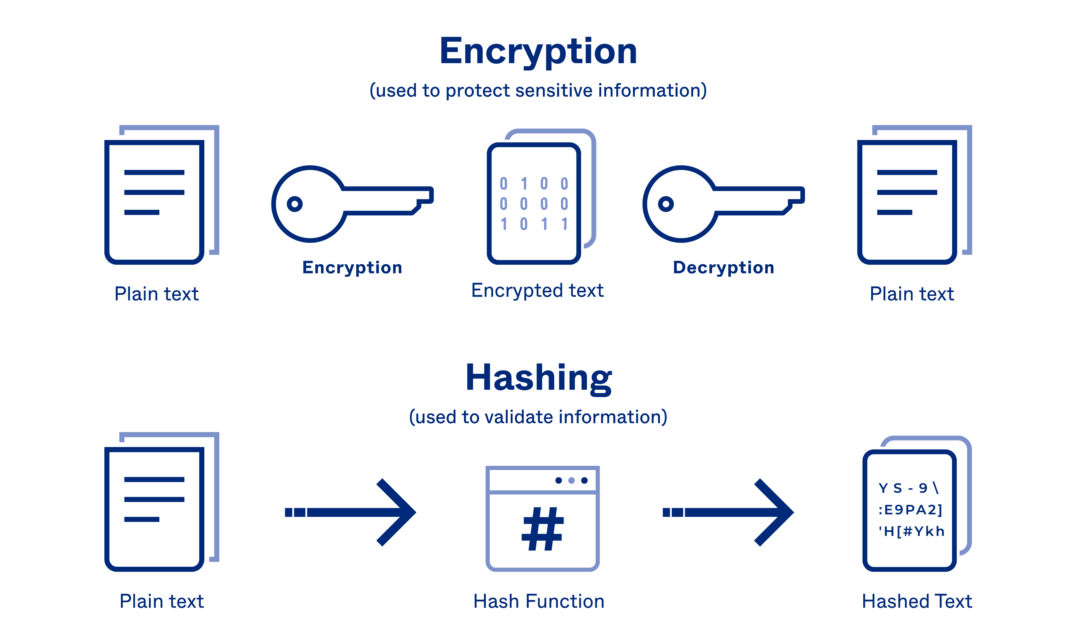

Real-World Scenario: Sending Secret Letters vs. Checking Cargo Seals.
Encryption Scenario (Encrypted Messaging App): When you send a message on WhatsApp, your phone uses encryption to scramble your text ("Meet me at noon") into gibberish ("U2FsdGVkX1...") while it travels across the internet. When your friend receives it, their app uses a digital key to decrypt it back into readable text. If a hacker intercepts the message in transit, they only see meaningless code.

3. Authentication vs. authorization

Authentication and authorization are both important security mechanisms, but they serve different purposes. Authentication verifies who a user is, usually through credentials such as a username and password, biometrics, or a verification code. Authorization determines what an authenticated user is allowed to access or perform within a system.
Real-World Scenario: Entering a Building vs. Accessing a Restricted Room
Authentication Scenario (Entering a Building): When you enter an office building, you may be required to scan your ID card or provide a biometric scan. The system checks your identity to confirm that you are actually the person associated with those credentials.
Authorization Scenario (Accessing a Restricted Room): After entering the building you may only be permitted to access certain rooms based on your role. For example, an employee might access their department's workspace, while only authorized administrators can enter the server room. This determines what actions or resources the authenticated user is permitted to access.

